Instruction : You’re Midterm Hands On Exam Will be compose of 3 Simple program that you need to accomplished and Create. Each Program should be name accordingly.

**Midterm Hands On no 1.**

Create a program a named it **Favorite_Word.py**. This program will ask for the user about his /her 4 favorite word then will display it . but the first to display is the last fav. Then the first word . and the second and third word are together.

Example Output: 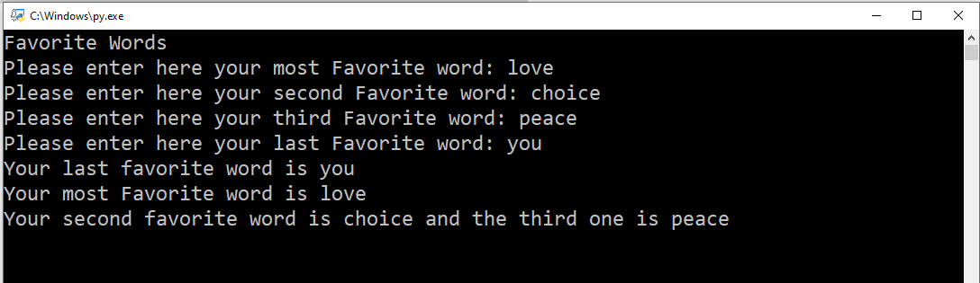

**Midterm Hands On no 2.**

Create a program a named it **Grading_System.py**. Create a program that will accept Prelim , Midterm , and Final Grades. The program will display the general average and remark a Congratulations! You passed the course . if the general average is 75 and above otherwise display Sorry you failed.

**Note:**

1. The program will use the computation Prelim + midterm + final divided by 3.
2. Also the program will not accept number that is below 55 and above 95. And will tell which grades is invalid.
3. If all grades are valid that’s the time the program will compute the final grades

Example Output:



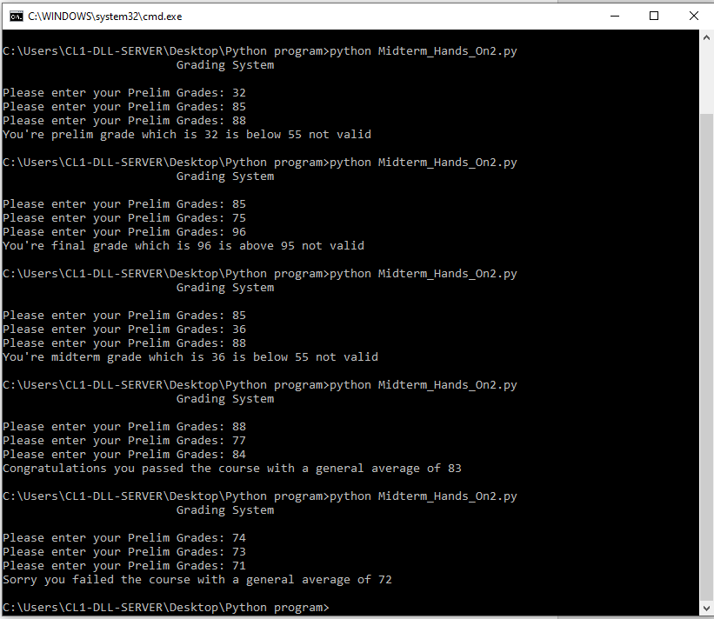

Midterm Hands On no 3.

Create a program name Odd_Even.py. The program will Accept 3 whole number from the user and will tell whether the number is odd or even then . how many is even and how many is odd.

Sample Output: